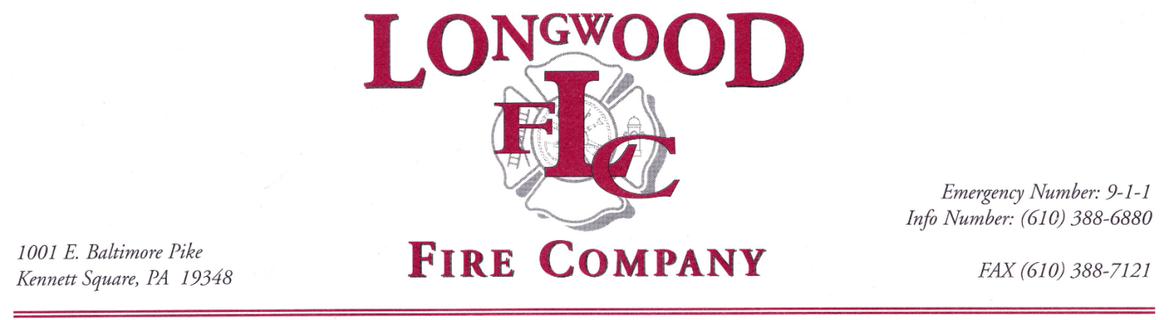
Employment Opportunity

Longwood Fire Company is seeking one experienced, highly motivated individual with a strong fire service work ethic to work as a full-time Firefighter/EMT within our combination fire company. This position is assigned to the Fire/Rescue division and currently works a 4 day 10-hour shift Monday through Thursday.
Longwood Fire Company offers an extremely competitive salary and benefits package, to include but not limited to, vacation, sick time and personal time, retirement with fire company match, expanded health insurance program, short/long term disability and life insurance coverage.
Interested parties that meet the qualifications contained within the job description should submit an application, resume and cover letter to Longwood Fire Company, attention Fire Chief, 1001 E. Baltimore Pike Kennett Square, Pa. 19348 no later than August 24, 2018 at 4:00 P.M.
The employment application and job description are available online at www.longwoodfireco.com or contact the Fire Company at 610-388-6880 or amccarthy@longwoodfireco.com
Hiring Process: Applications will be reviewed and scored. Consideration for interviews will be based off scoring of certification level and experience. Finalist will be required to complete medical exam/drug screening, extensive background check, pre-employment NFPA physical and other required background checks.
Longwood Fire Company is an EEO organization.
A.J. McCarthy

A.J. McCarthy
Fire Chief

